**MongoDB**

1. Find all the information about each products

**db.products.find()**

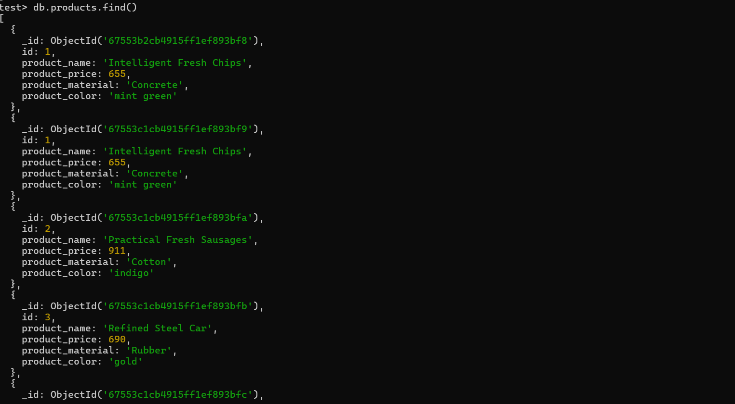

1. Find the product price which are between 400 to 800

**db.products.find({product_price: {$gte: 400, $lte: 800}})**

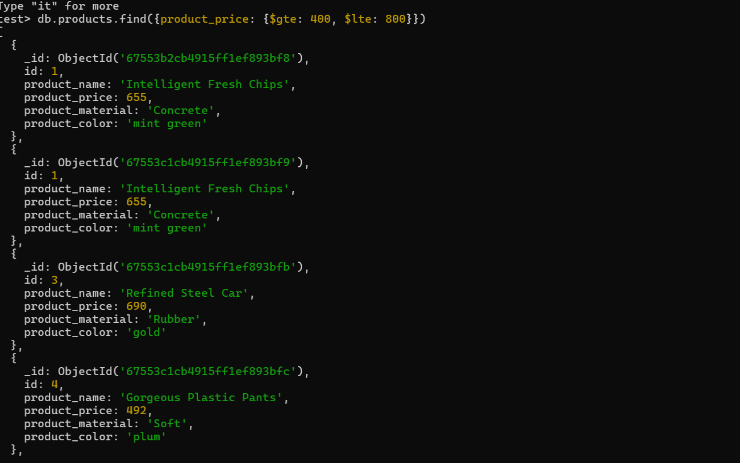

1. Find the product price which are not between 400 to 600

**db.products.find({product_price:{$not: {$gte: 400, $lte: 600}}})**

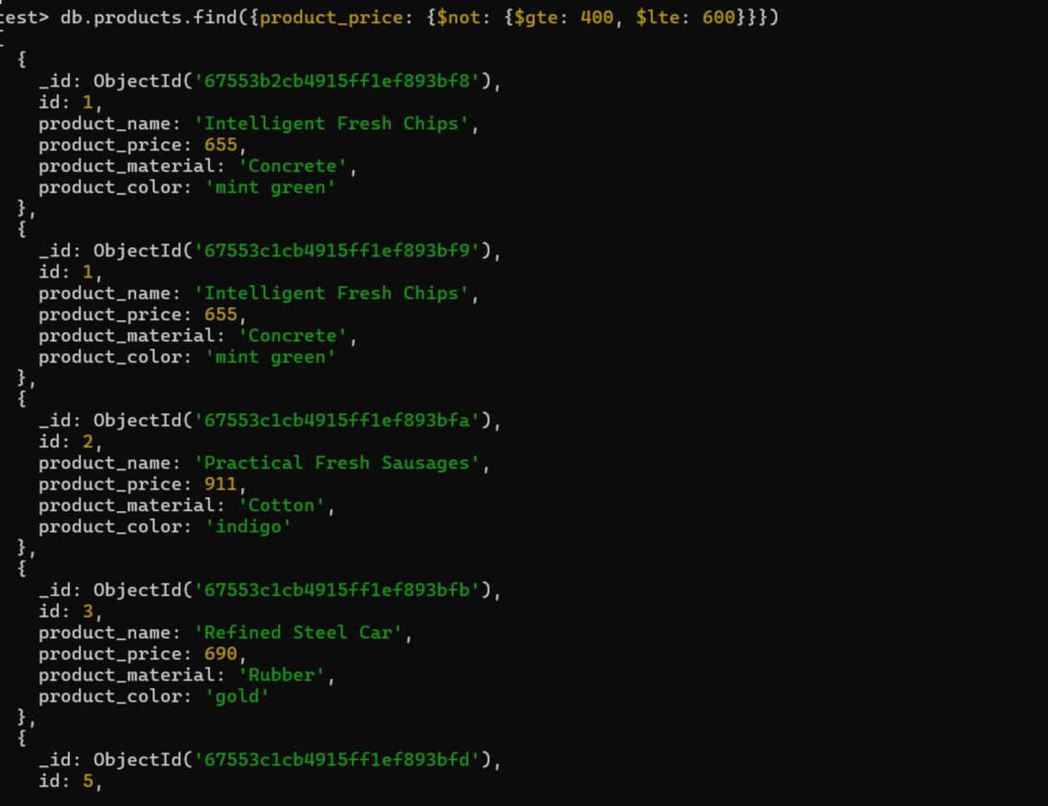

1. List the four product which are greater than 500 in

**pricedb.products.find({product_price:{$gt: 500}}).limit(4)**

1. 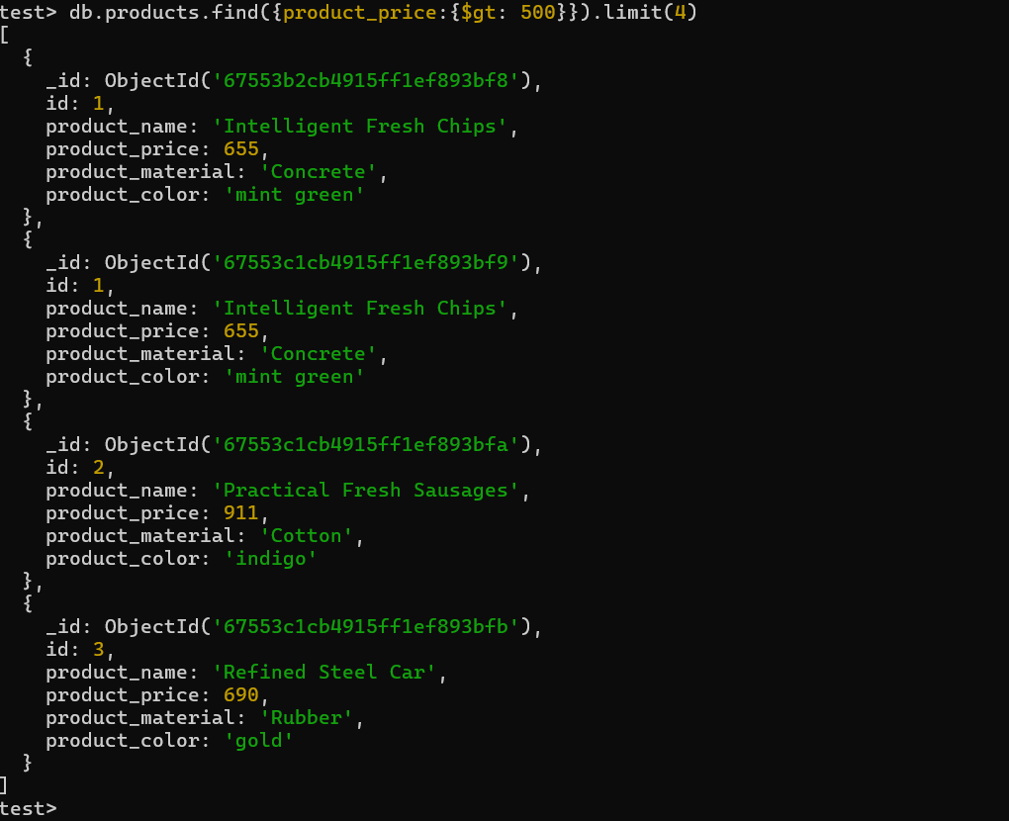

5. Find the product name and product material of each products.

**db.products.find({}, {product_name:1, product_material: 1, _id:0}).pretty()**

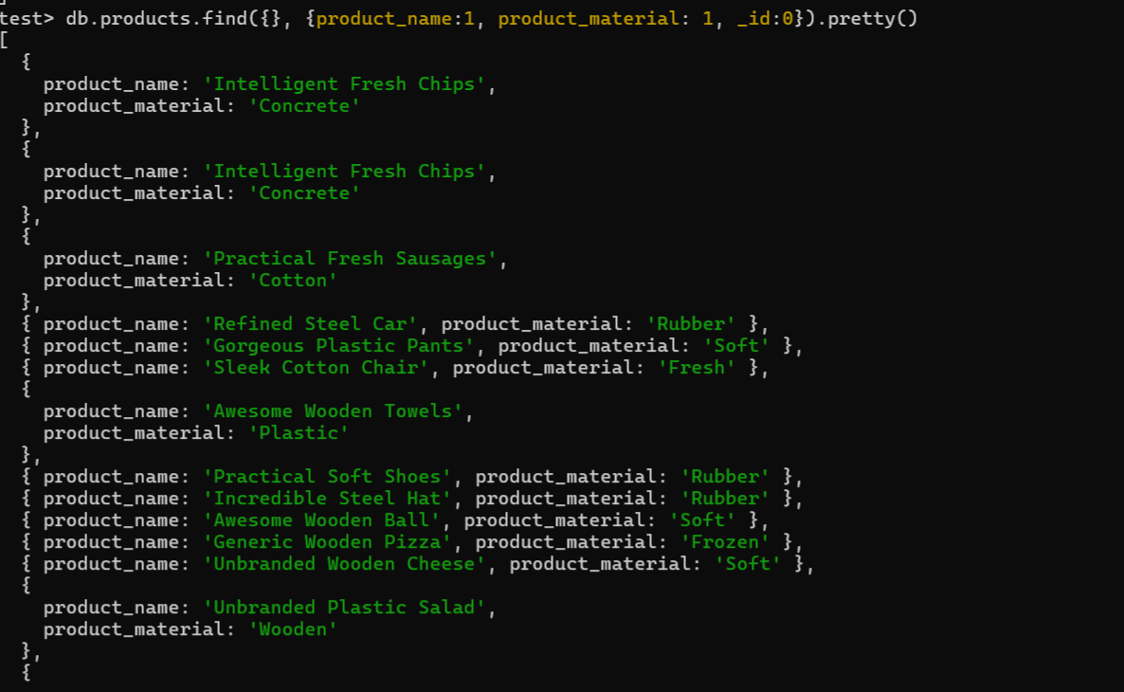

6. Find the product with a row id of 10

**db.products.find({id: 10})**

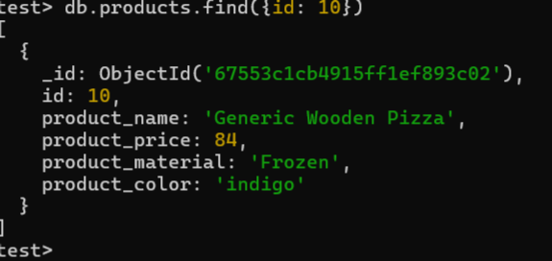

7. Find only the product name and product material

**db.products.find({}, {product_name: 1, product_material: 1, _id: 0}).forEach(doc => {print(`Product Name: ${doc.product_name}, Product Material: ${doc.product_material}`)})**

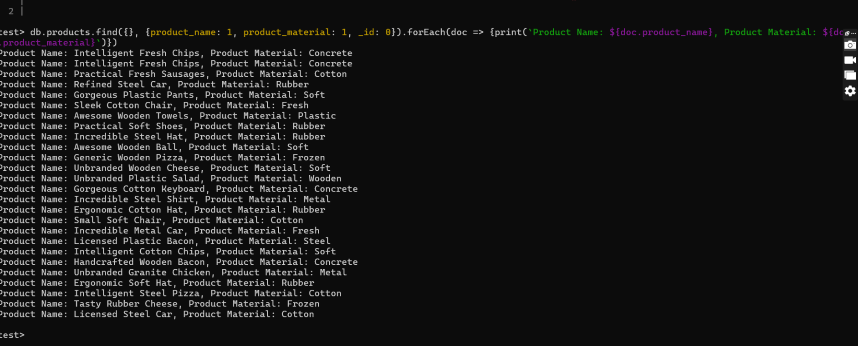

8. Find all products which contain the value of soft in product material

**db.products.find({product_material: {$regex: /soft/i}})**

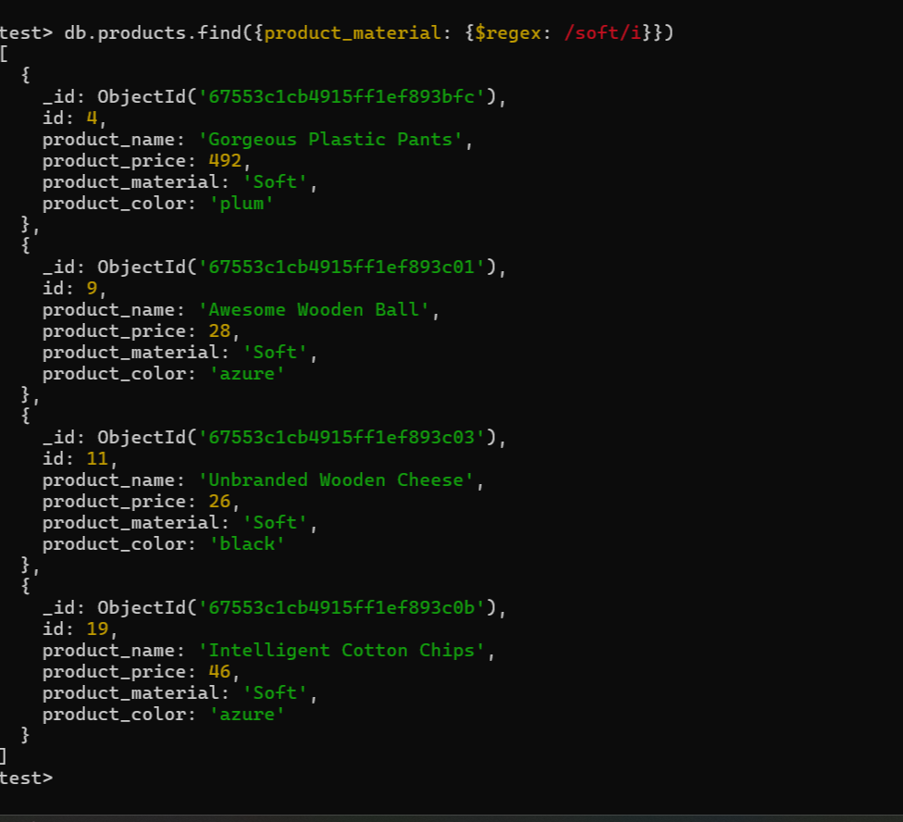

**db.products.find({product_material: {$eq: 'Soft' }})**

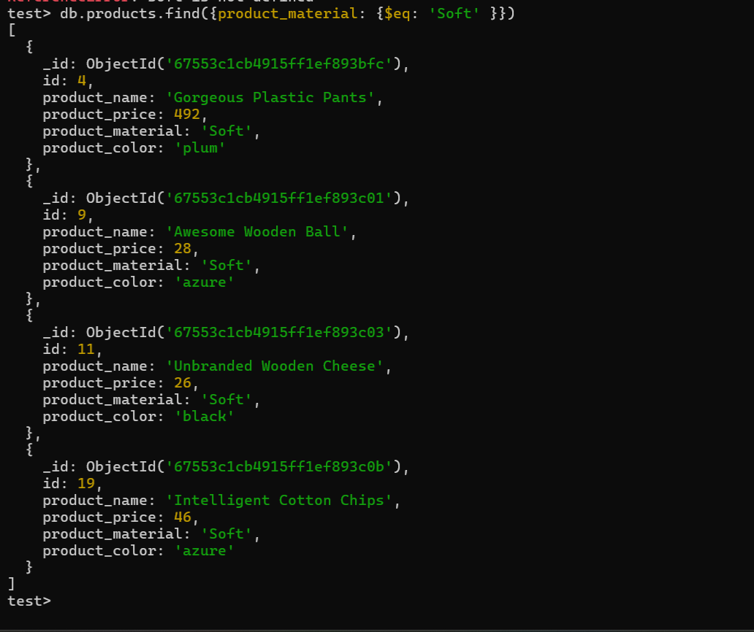

**9. Find products which contain product color indigo  and product price 492.00**

**db.products.find({ $or: [{product_color: "indigo"}, {product_price: 492.00}]})**

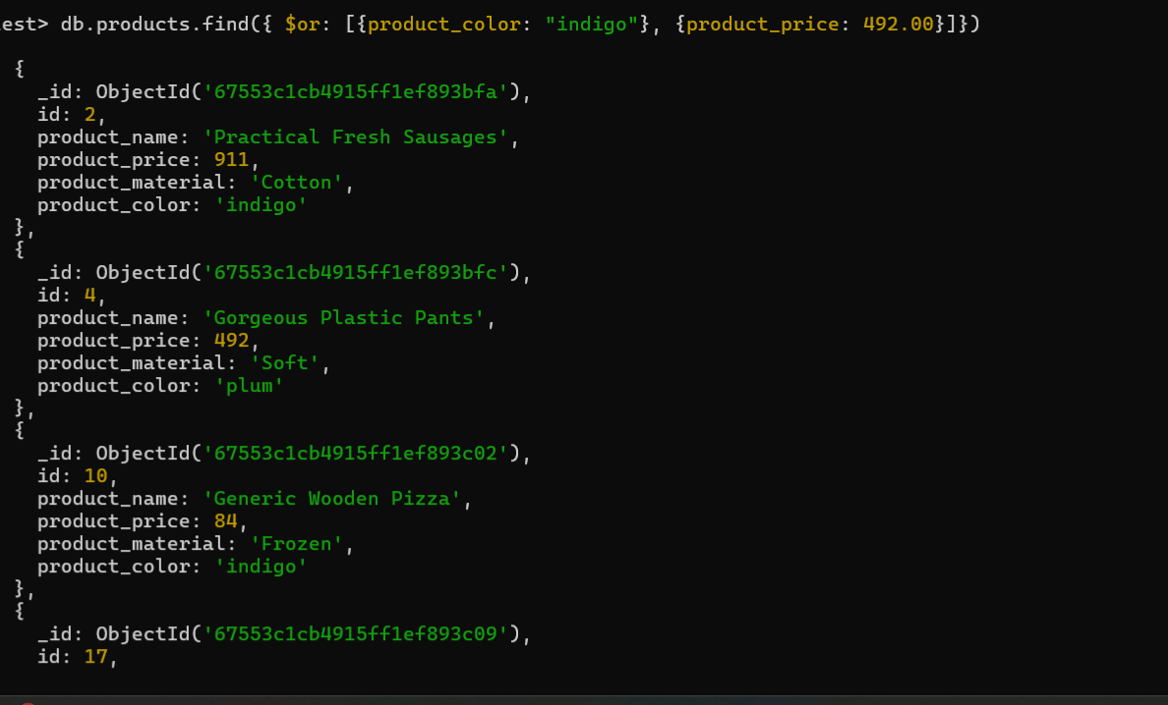

**10. Delete the products which product price value are 28**

**db.products.deleteMany({product_price: 28})**

